|  |  |  |  |
| --- | --- | --- | --- |
| Quantity | Description | Unit Price | Total |
| 1.0 | Sponsorship package for the Chelmsford Round Table fireworks display 6th November 2021 | £500 | £500 |
|  | | | £500 |

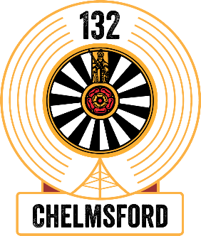

Invoice # 2021-108

Date 12/10/2021

Please make payments to our CAF account;

Chelmsford Round Table Charity Account

A/C No: 00029816

Sort code: 40 52 40

Address: 111 Millfields,

Writtle,

Essex,

CM1 3LJ

Teledyne e2v – UK

106 Waterhouse Lane

Chelmsford

Essex

CM1 2QU